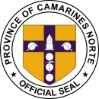[Your Name]

[Your Address] [City, State, ZIP] [Email Address]

[Phone Number] [Date]

Museo Bulawan

3 Justo Lukban St, Daet, 4600 Camarines Norte, Philippines

PROVINCE OF CAMARINES NORTE

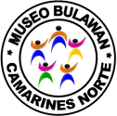**MUSEUM, ARCHIVES AND SHRINE CURATION DIVISION**

**Subject**: Request for Interview at Museo Bulawan

Dear Museo Bulawan,

I hope this letter finds you well. I am writing to request an interview with a representative from Museo Bulawan. As a [mention your profession or area of interest], I am eager to gain insights and knowledge about the rich cultural heritage and historical significance of Camarines Norte, which I believe Museo Bulawan beautifully represents.

I kindly request your assistance in arranging this interview, and I am open to the following instructions:

1. Interview Availability: Please provide me with available dates and time slots for the interview. I am flexible and willing to accommodate your schedule to ensure a convenient time for both parties.
2. 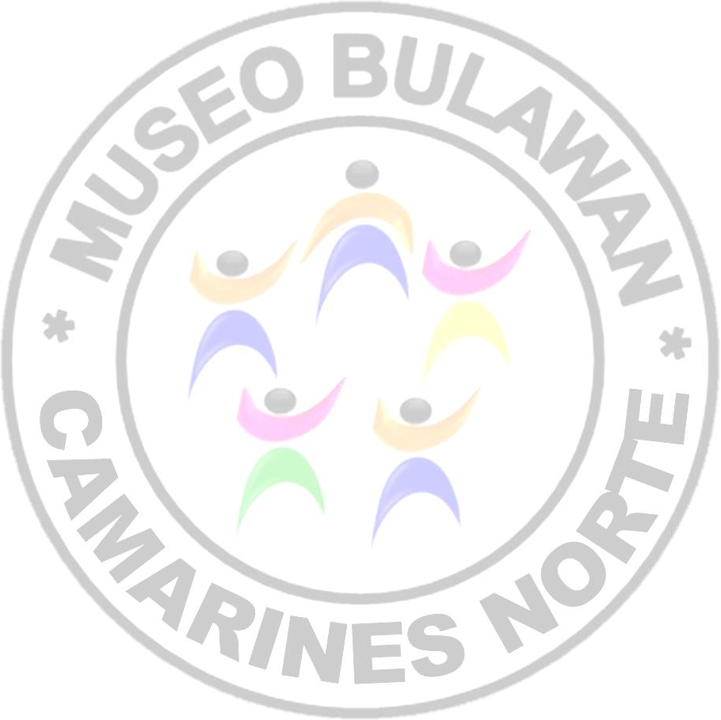Interview Format: Kindly inform me of your preferred interview format, whether it be an in-person interview at Museo Bulawan or a virtual interview conducted via video conference. Please specify any technical requirements or platforms to be used for the virtual interview, if applicable.
3. Interviewee: If there is a specific representative or expert at Museo Bulawan whom you recommend for the interview, kindly provide their name and contact information. If there are multiple individuals who can provide valuable insights, I would greatly appreciate the opportunity to interview them as well.
4. Interview Topics: While I am particularly interested in exploring the history, cultural traditions, and significant artifacts housed in Museo Bulawan, I am open to discussing any other relevant topics suggested by the museum. Please let me know if there are specific areas of focus or if there are any specific questions you would like me to address during the interview.

Thank you in advance for considering my interview request. I am excited about the opportunity to learn from the knowledgeable individuals at Museo Bulawan and share their valuable insights with a broader audience.

Please feel free to contact me at [Your Email Address] or [Your Phone Number] to discuss any details or to provide further information. I eagerly await your response and the possibility of conducting an interview with Museo Bulawan.

Yours sincerely, [Your Name]